In-term Test Q4 2025-2026

This paper consists of SIX practice questions, carrying a total of 100 marks. Questions 1 and 2 are worth 10 marks each, while questions 3 to 6 carry 20 marks each.
Students have 90 minutes to answer all the questions. No extra time is given for reading the questions. Additional Exam Booklet is provided on Moodle. Students use computers with MySQL or SQL Server to complete the questions.
Students must submit the Exam Answer via Moodle. (script .sql and report as .pdf)
File Name format: MIS443_ID_FullName.zip.
----------------------------------------------------------------------------------------------------------------
Scenario:
This dataset represents Northwind Traders, a mid-sized international trading company that sells food and beverage products to business customers. The database captures essential information about customers, orders, products, and shipping activities. The primary goal of this database is to support data-driven insights into customer purchasing behavior, order activity, and delivery operations, enabling the company to improve sales performance, optimize logistics, and make informed operational decisions.
- Customers: Stores each customer’s unique ID and company information (e.g., company name, contact details, location). This table supports customer segmentation and relationship management.
- Orders: Records each order placed by a customer, including order date, shipping date, and shipping method. It provides the foundation for analyzing order frequency and delivery performance.
- Order_Details: Contains line-item details for each order (products, quantities, unit prices, and discounts). This table supports transaction-level analysis of product demand and sales patterns.
- Products: Lists all products sold by Northwind, including product name and related product attributes. It is used to analyze demand across different products.
- Shippers: Contains shipping partner information used to deliver orders. This table supports evaluation of logistics and shipping performance.
In addition, students must create a new table named “students”. This table should include three attributes: studentid, fullname, and email. You may decide the appropriate data types and length for each attribute.
Note: The SQL script for loading the Northwind tables (include 14 tables) is available on Moodle. Only the “students” table must be created entirely by the student.
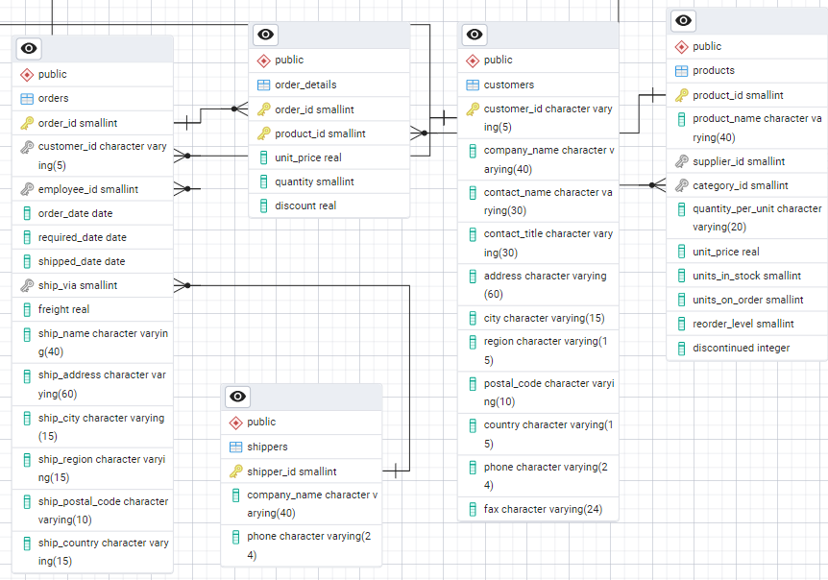
ER Model (five main tables)
Question 1 (10 marks): Database Setup (10 marks)
Using PostgreSQL and pgAdmin:
- Create a database named yourfullname. Then move all Northwind tables into this schema. (5 marks)
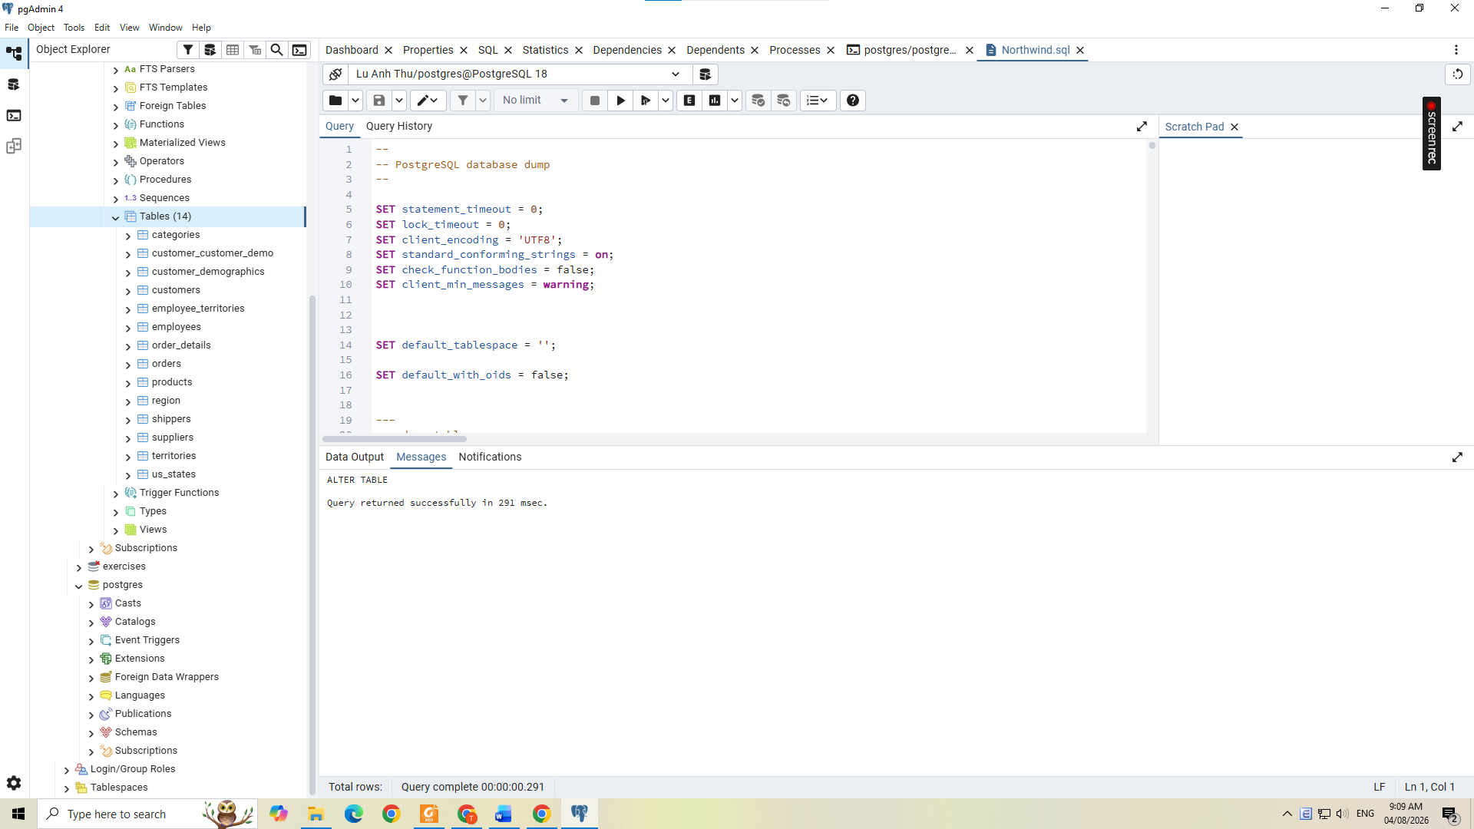
(b) Create a new table called students inside schema exam with the following columns:
Studentid: 5-digit number, Primary Key
Fullname: Required
Email: Must be unique
Insert your own information into the table. (5 marks).

-- Test results
SELECT table_name, column_name, data_type
FROM information_schema.columns
WHERE table_schema = 'public'
ORDER BY table_name, ordinal_position;
Sample Output:
Results 1: Verify result from load and create database
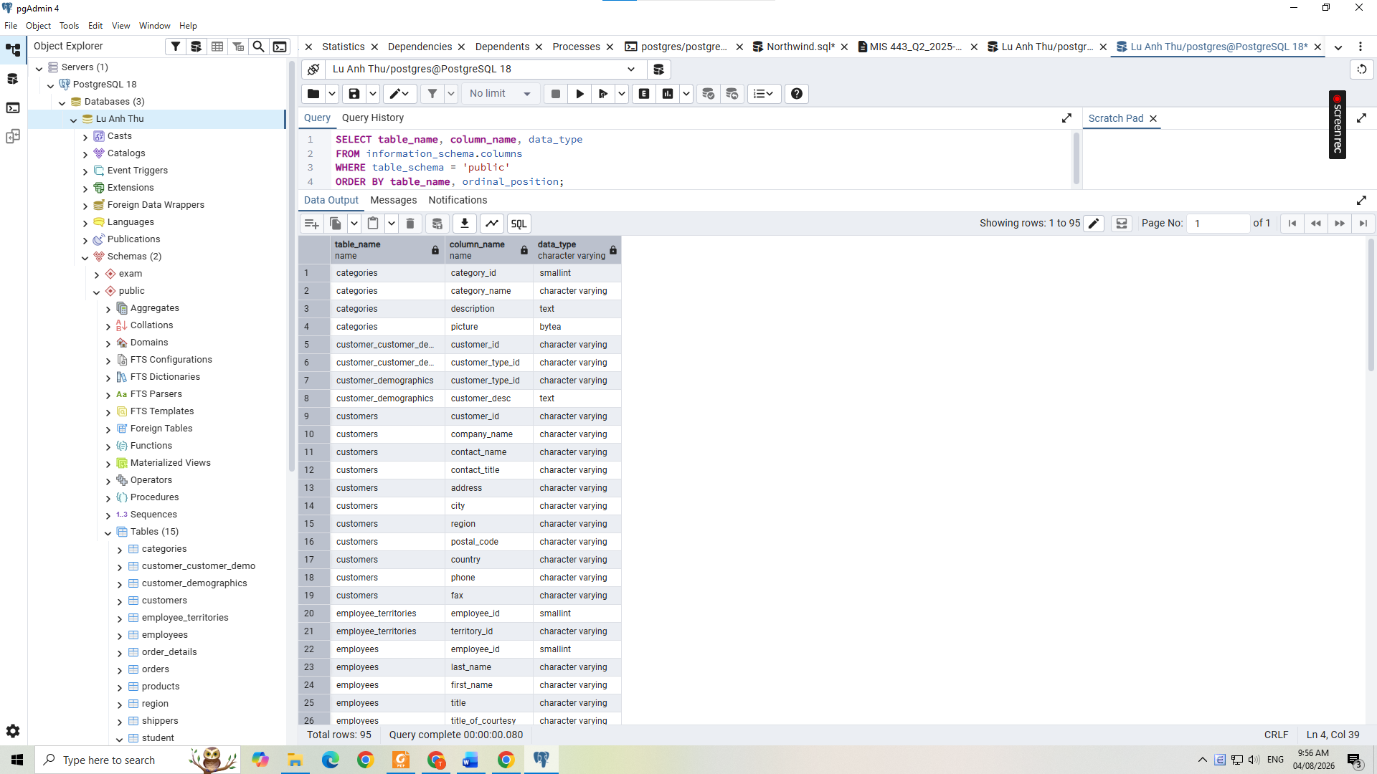
Results 2: Verify result from table student

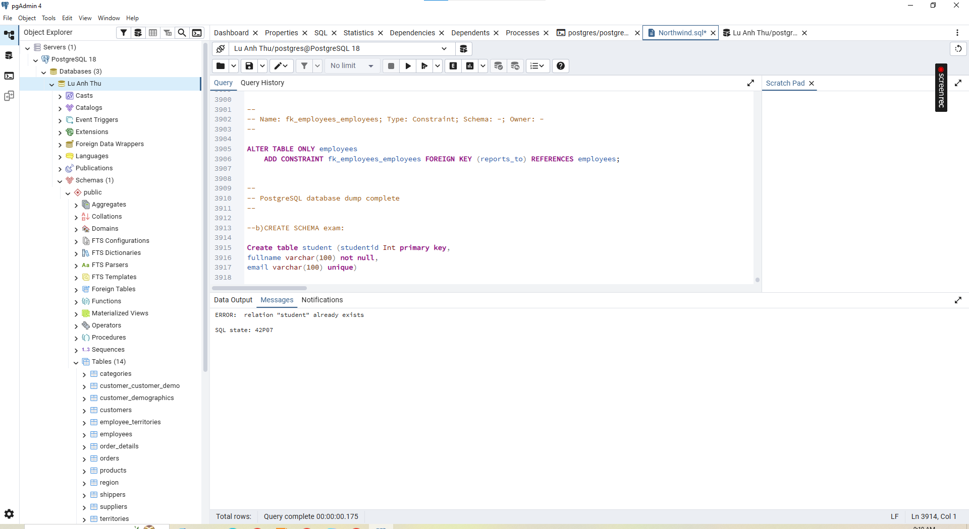
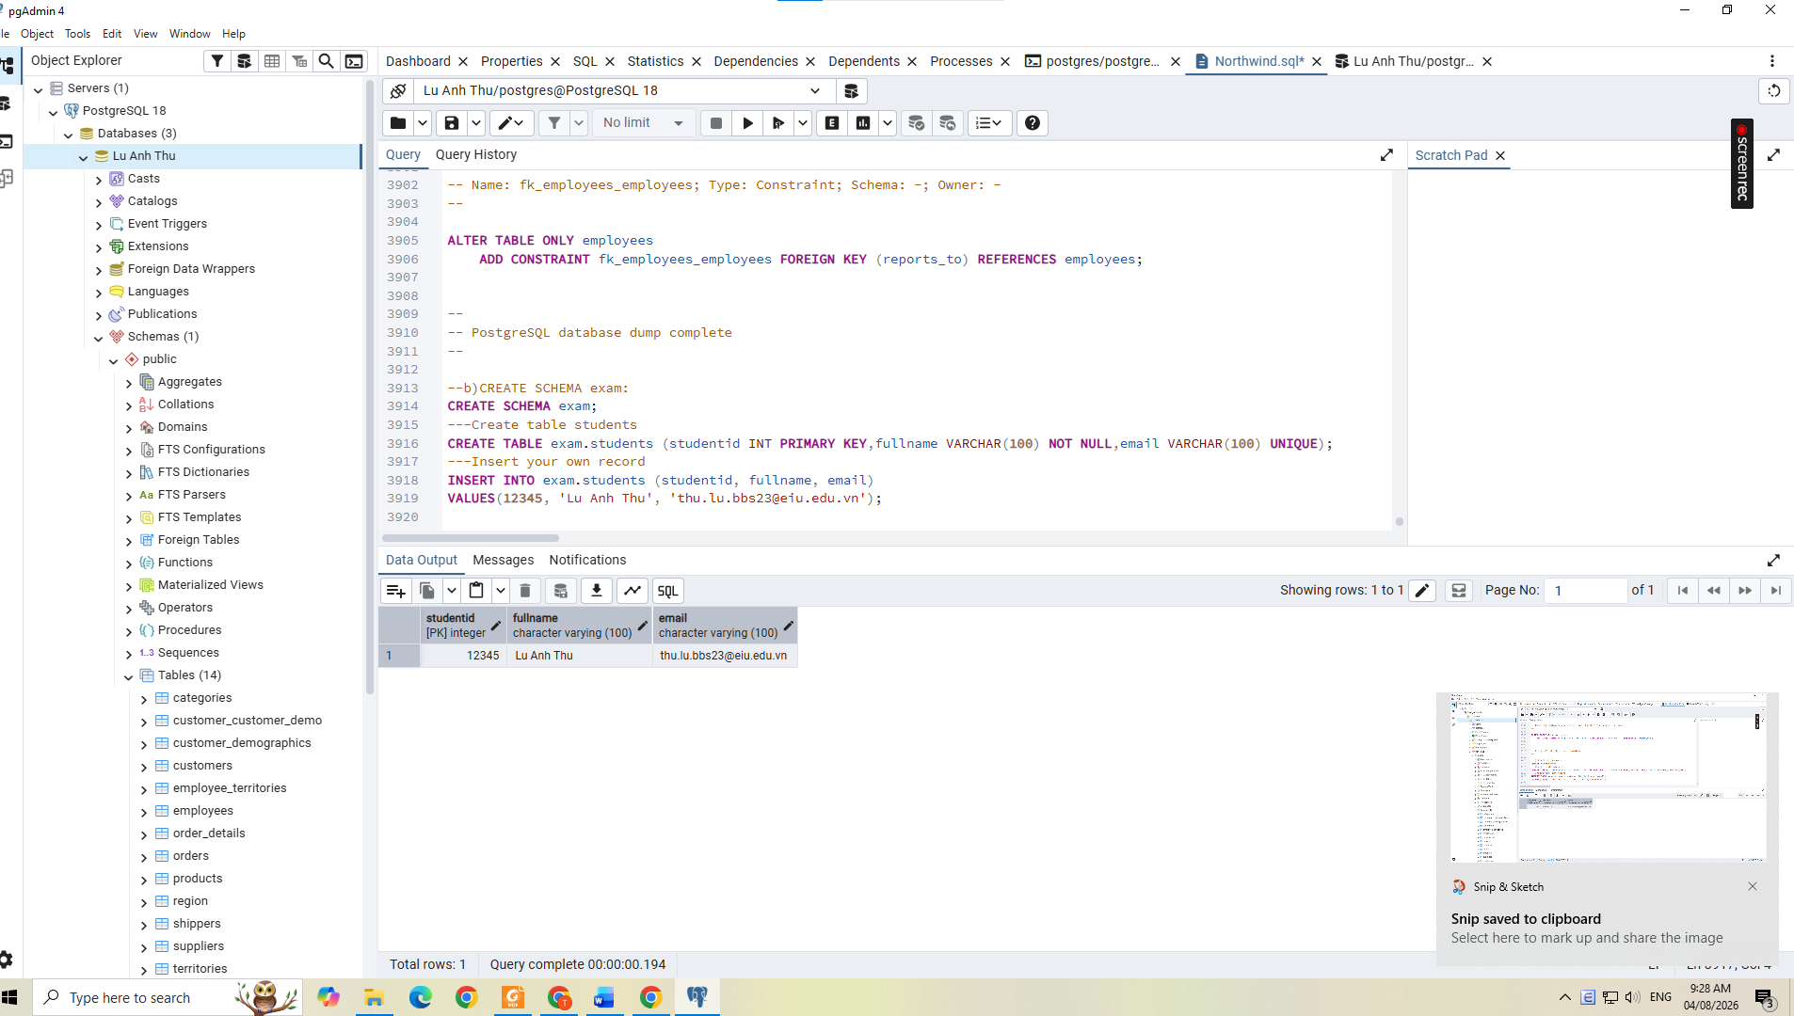
Question 2 (10 marks): Write an SQL query to find the top 5 customers who placed the highest number of orders.
Output
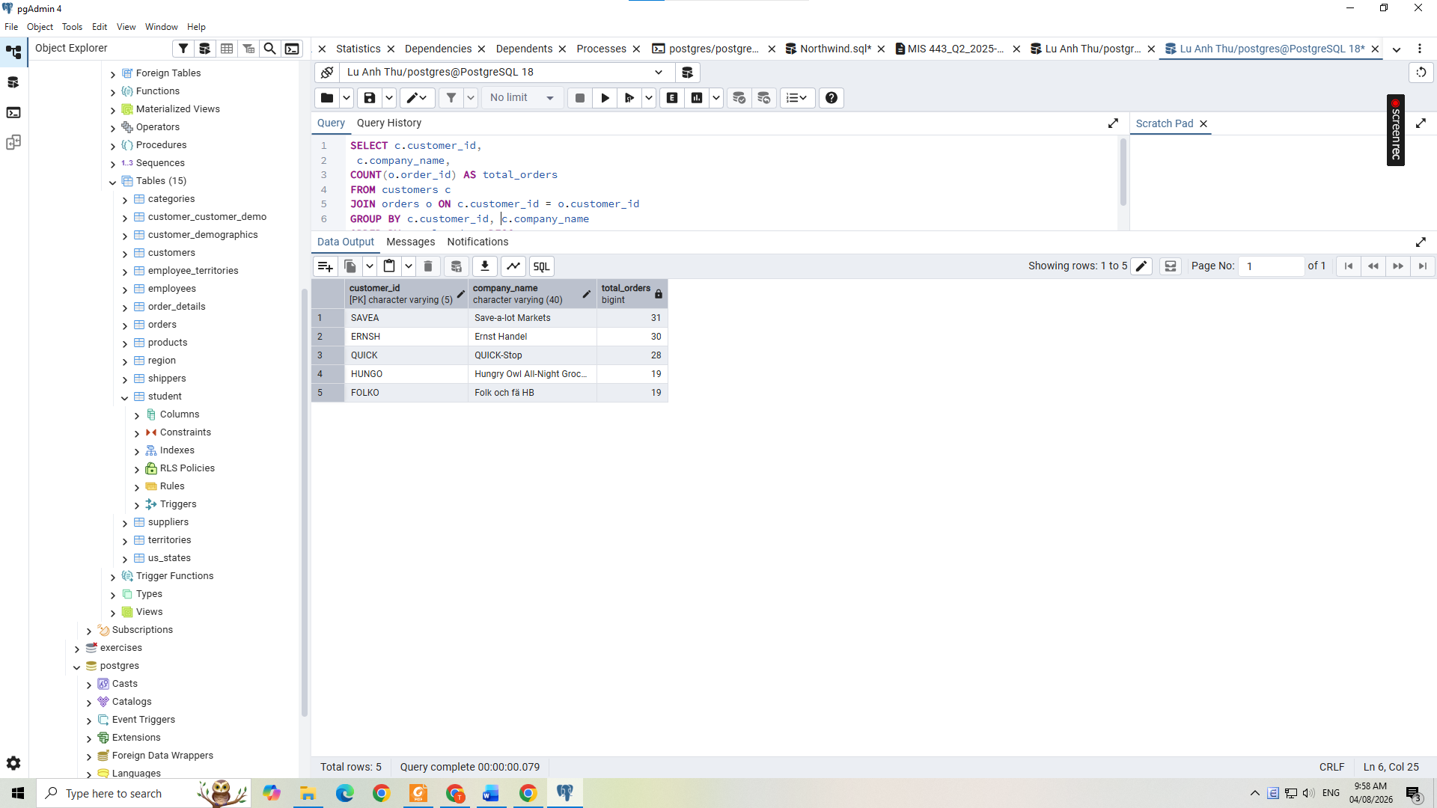
Question 3 (20 marks): Write an SQL query to display a list of orders and the customers who made them. Sort by order date (newest first).
Output:
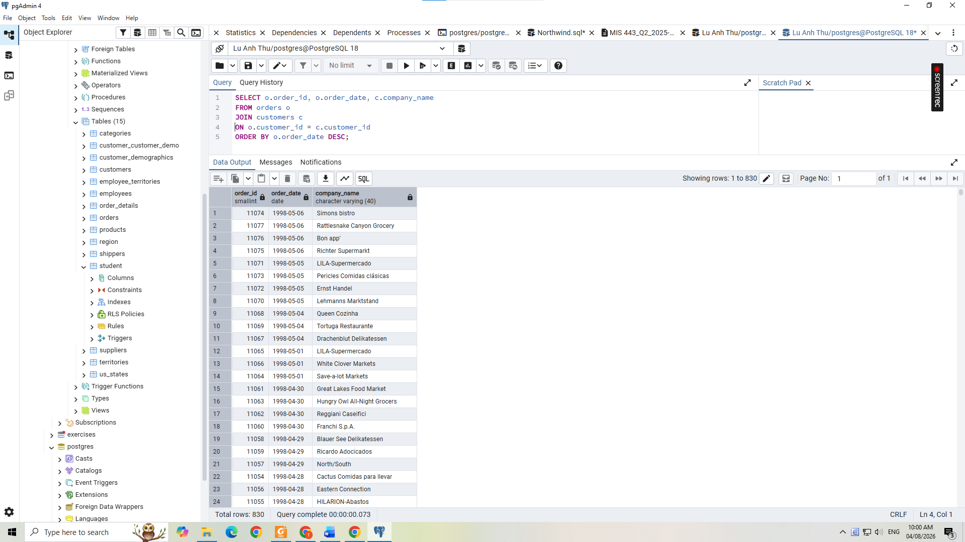
Question 4 (20 marks): Northwind management wants to identify large product movements to better plan inventory and logistics. Write an SQL query to display orders where a product was purchased in large quantity (more than 99 units in a single order).
Output:
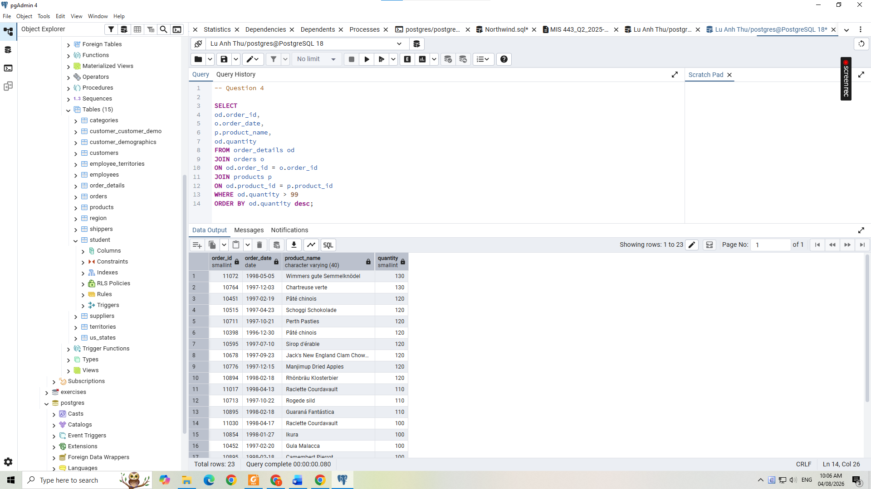
Question 5 (20 marks): Northwind management wants to understand which product categories generate the most sales to guide marketing and purchasing decisions. Write an SQL query to calculate the total quantity of products sold for each category.
Output:

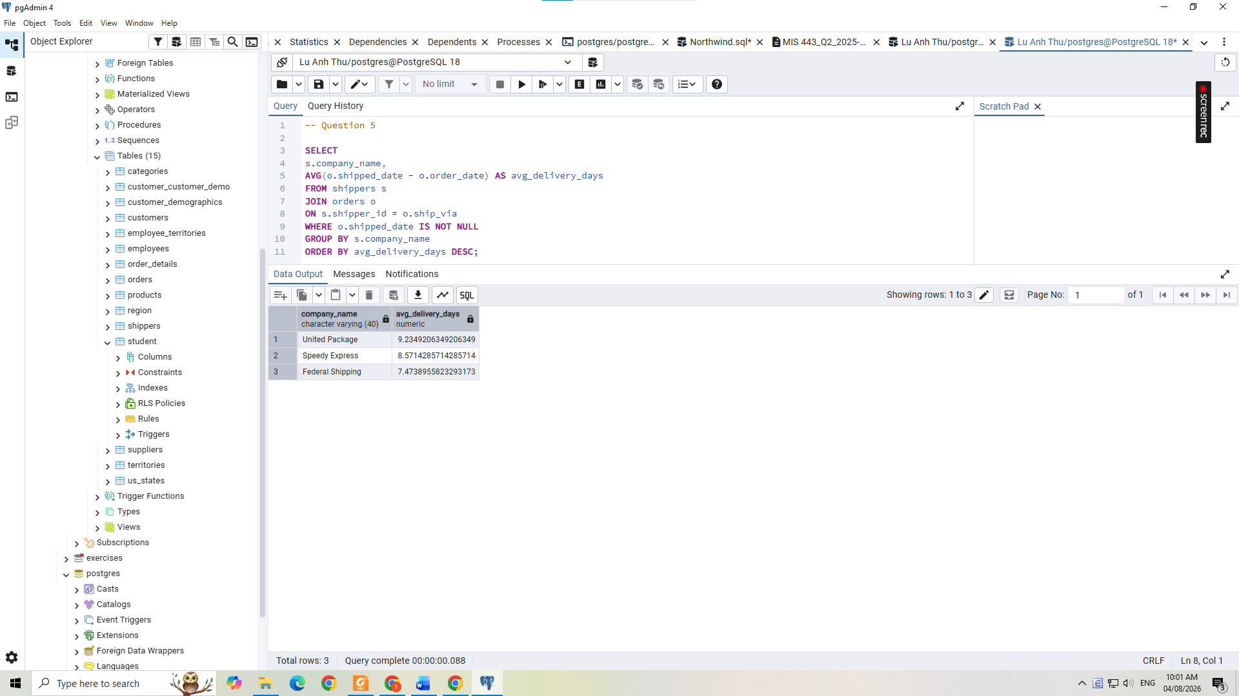
Question 6 (20 marks): Northwind wants to identify the most active customers (customers who place orders most frequently) to target retention campaigns. Write an SQL query to rank customers based on their total number of orders (highest = rank 1). Customers with the same number of orders must have the same rank.
Output:
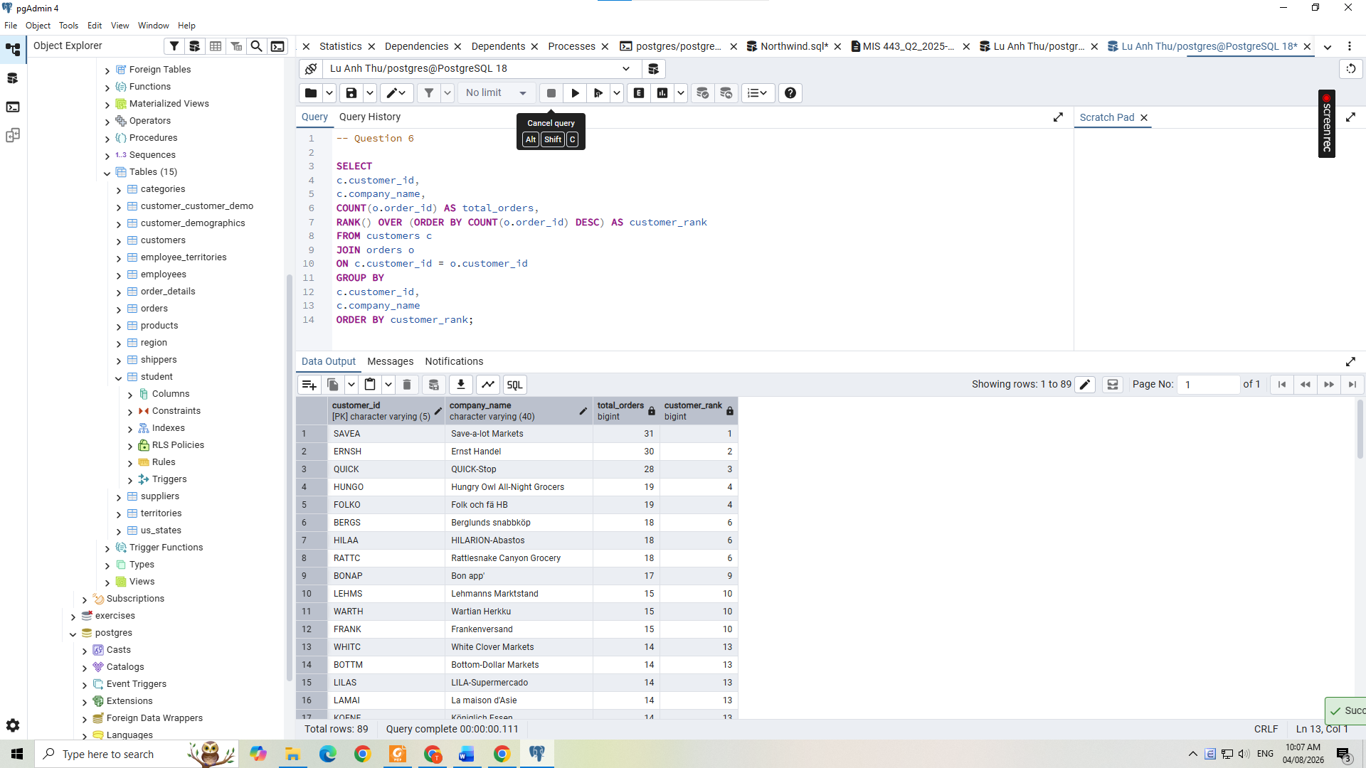

------ End ------

